**FOURTH GENERATION OF COMPUTER**

**The fourth generation of computers** was introduced in 1971. They used the very large scale integrated (VLSI) circuits, which developed from small integrated circuits. Very large scale integration is a process where a thousand transistors are combined into a chip to create an integrated circuit. They were invented in 1970 using a microprocessor. The microprocessor was invented by Ted Hoff and named it Intel 4004, the first ever computer on a chip. The chips allowed computers to fit on a desktop.

[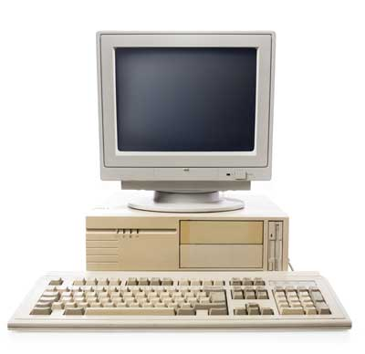](http://www.pixuffle.net/wp-content/uploads/2018/06/fourth-generation.jpg)

It also introduced office automation, word processing, report writing, spreadsheets and also query languages

**The main features of the fourth generation of computers include:**

**1.The used the technology of very large scale integrated (VLSI) circuits**  
**2.They do not require an AC**   
**3.They got introduced to the concept of the Internet**  
**4.They were very cheap**  
**5.They were very fast and reliable**  
**6.They also introduced the mouse**  
**7.They were easily available to everyone.**  
**8.The main memory increased in the form of EPROM and SRAM**  
**9.The software was simpler to use and was very convenient**  
**10.The external storage was the floppy disk and hard disks.**

**Here are some examples of the fourth generation of computers:**

1.ALTAIR 8800– it was the first microcomputer. It was invented in 1975 by Ed Roberts who was the head of Micro Instrumentation Telemetry System (MITS) and named it a personal computer. He designed it with An Intel 8080 CPU and a sleek case made of metal. When the keyboard and monitor was introduced the sales increased worldwide. It could also run basic language. The computers sold for quite a while but when MITS was sold to another company PERTEC. He continued producing them but he did not a good job so they started to disappear.  
2.Apple Computers– The first original apple computer was invented by Steve Wozniak in 1976. It was the first product of apple and was produced as a personal computer. He was helped to sell the computers by his friend Steve job who later on helped him manufacture the Apple 2. Eventually Steve jobs and Steve Wozniak were the co-founders of Apple. The second apple really sold in large numbers and was very successful. Around five million apple computers were sold at the end of 1993. In 1994 apple introduced Macintosh that was also very successful which is now being used in publishing the desktops.  
3.IBM PC  
4.STAR 1000  
5.CRAY  
6.VAX9000

In the fourth generation computers micro-soft was introduced. Micro-soft was invented by Bill Gates and Paul Allen. It started out as making the operating systems and the programming languages. They collaborated with many companies and eventually created different systems for the different computers in that time.

**Some of the advantages of the fourth generation of computers include:**

1.It was the cheapest  
2.It was reliable and powerful compared to the other generations  
3.It was smaller in size  
4.It did not require cooling systems  
5.It could be used for commercial production  
6.It is fast in computation

**The fourth generation computers also had some disadvantages which include:-**

1.Technology was a problem because most countries did not have ICs  
2.It required high skilled staff for manufacturing  
The major differences between the third generation of computers and the fourth generation of computers include:-  
1.The [third generation](http://www.pixuffle.net/third-generation-of-computer/) of computers used integrated circuits while the fourth generation of computers used the very large scale integrated (VLSI) circuits.  
2.The third generation of computers measured the operating speed in nanoseconds while the fourth generation of computers measured the operating speed in Picoseconds and MIPS(Millions of instruction per second)  
3.The third generation of computers did not have the Internet while the fourth generation of computers had the Internet.  
4.The third generation of computers did not use the operating system while the fourth generation of computers used the operating system.  
5.The third generation of computers memory increased in the form of PROM and DRAM while the fourth generation of computers the memory increased in the form of EPROM and SRAM.  
6.The third generation of computers used the magnetic disks for external storage while the fourth generation of computers used the floppy disks and hard disks.  
The fourth generation of computers is an extension or improvement of the third generation of computers.